IB Criteria Draft Checklist
IB Lang & Lit HL Essay
Companion to 2024 Subject Report

IB Assessment Criteria - Draft Checklist

Criterion A: Knowledge, understanding, and interpretation / 5 marks
- How well does the candidate demonstrate knowledge and understanding of the work or body of work chosen?
- To what extent does the candidate make use of knowledge and understanding of the work or body of work to draw conclusions in relation to the chosen line of inquiry?
- How well are ideas supported by references to the work or body of work in relation to the chosen line of inquiry?

- Make sure your line of inquiry refers to a sufficiently large work (novel) or two or more texts in a body of work (poetry collection, selected blog posts, set of cartoons, series of photographs).
- Troubleshoot your line of inquiry and thesis statement to make sure they center authorial choices and/or textual features of the body of work studied, rather than focusing foremost on contextual, historical, or biographical topics.
A PERSUASIVE INTERPRETATION requires candidates to select, analyze, and comment on SPECIFIC FEATURES of the work which relate to and support the chosen line of inquiry.
(specific features = evidence in the text)
- Bold in your draft every time you reference a specific textual feature or quote from the text. Check that you’ve included a range of features relevant to your text type.
  - Remember to unbold the sentences after you're done with the following steps.
- Make sure you directly reference examples or instances of each textual feature you identify (and include parenthetical citations when you do!). These direct references and quotations are the evidence for your analysis and interpretation, and should appear in most if not all of your body paragraphs.
- Make sure each direct reference and quotation you selected is specific and relevant to your line of inquiry.
- Concluding paragraphs consider and analyze how representative your text selections are of the work (novel) or body of work (poetry collection, selected blog posts, set of cartoons, series of photographs).
Criterion B: Analysis and evaluation / 5 marks
- To what extent does the candidate analyse and evaluate how the choices of language, technique and style, and broader authorial choices shape meaning in relation to the chosen line of inquiry?

“It is not enough to simply identify a specific feature without discussing the effects created.” - Subject Report Nov 2021

- Make sure your essay includes and explores a range of relevant techniques in your chosen text type.
- Complete the paragraph diagnostic to make sure you’re including evidence and analysis and not just description.
Criterion C: Focus, organization, and development / 5 marks
- How well organized, focused and developed is the presentation of ideas in the essay?
- How well are examples integrated into the essay?

- Do the Reverse Outline Quick-Check to refine your draft essay structure and organization (links to Vanderbilt professor’s reverse outline handout).
- NEED TO CUT WORDS? Try this exercise!
Criterion D: Language / 5 marks
- How clear, varied and accurate is the language?
- How appropriate is the choice of register and style? (“Register” refers, in this context, to the candidate’s use of elements such as vocabulary, tone, sentence structure and terminology appropriate to the HL essay).

- Make sure your essay aligns with the conventions for lang & lit academic essays.
- Replace “to be” verbs and vague or repeated verbs with purposefully chosen strong verbs.
- Read drafts and revised paper aloud to catch mistakes and awkward phrasing.

Essay Master Checklist: Formatting and Content

Essay Composition Master Checklist: Formatting and Content

Introduction | - Identifies the work or body of work focused upon.  - Establishes line of inquiry that explicitly examines authorial choices and how they generate meaning, or incorporates contextual elements but approaches them from a literary or linguistic perspective.  - Thesis statement clearly indicates the relevant features of the work(s) and the interpretation you will argue and provide evidence for.
Body Paragraphs | - Each body paragraph begins with a topic sentence that establishes the interpretive claim elaborated in the paragraph and the component(s) or feature(s) of the work(s) that you analyze to support it. Interpretive claim connects the line of inquiry to the textual evidence considered.  - Each paragraph provides textual evidence for a particular claim, including quotation(s), references to specific features of the work or specific repeated or related features across a body of work.  - Each paragraph ends with a transitional sentence that links the interpretive claim of that paragraph to the topic, claim, or focus of the next–that is, connects the interpretation to its meaning as part in relation to other parts in the context of the whole. (Or, a transitional phrase at the beginning of the next paragraph’s topic sentence provides the link.)
References / Textual Evidence | - Every quotation is embedded in a sentence that integrates or flows smoothly with the surrounding sentences. No isolated quotations.  - Every quotation from, paraphrase of, or direct reference to the work(s) includes a parenthetical citation before the period of the sentence.  - If writing about a graphic novel, TV show, advertisement, film, etc., then embed the relevant panels/texts/stills being analyzed within the body of the essay.  - Hyperlinks won’t work in examiners’ copies, so either include the linked work(s) in an appendix or provide clear and complete reference information to allow the examiner to access the material.  - Works Cited page with complete citations for all work(s) referred to or written about.
Conclusion | - Answers the Line of Inquiry by proposing a significant, persuasive re-/interpretation of the work(s) as a whole.  - States how that significant interpretation emerges as the culminating implication of the sustained analysis you developed, completing your essay’s line of inquiry.
Sentence-level | - Purposeful and accurate transitional phrases between sentences and paragraphs.  - Strong verbs  - Read essay aloud to check for errors or awkward moments in grammar and sentence structure.
Format | - Title Page [Double-check with your teacher for final formatting guidance]  English A: Language and Literature  Literary/Non Literary Body of Work: [Text Type] by [Author]  Higher Level Essay  Line of Inquiry: [“...?”]  Word Count: [####]

IB’s 10 Tps for the HL Essay
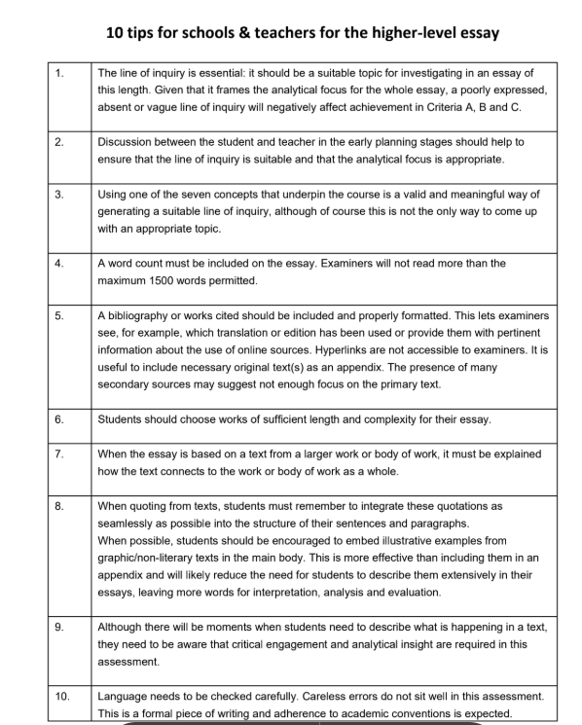

Paragraph Diagnostic and Revision

Paragraph Diagnostic for Revision

Instructions:
Paste your research question in the box below. Pick your longest body paragraph and paste it below your research question.

- Highlight in yellow the sentence(s) containing the key idea/a specific feature.
- Highlight in blue the transitional words or phrases throughout your paragraph.
- Highlight in orange the sentence(s) or phrase(s) that connect your key idea/feature to the evidence you will reference.
- Bold where you quote or directly reference the text(s). Look for:
  - Text title or location/context in the novel
  - Every quotation and reference is embedded (“quotation sandwich”), with a strong verb introducing the quotation/reference and followed by sentence(s) that analyzes and interprets the quotation or reference.
  - If referencing visual features, embed the image (with in-text citation) in the body of the essay. Like the quotation sandwich, include a specific description and location of the visual feature and follow up with sentence(s) that analyze and interpret the specific visual feature.
- Highlight in pink direct citations and quotations.
- Highlight in purple the sentence(s) connecting the evidence back to the line of inquiry. These sentences explain what part of the interpretive argument, or contribution toward the overall interpretation, you draw or conclude from the featured evidence.
- Highlight in green any sentences that do not connect or relate to the key idea already highlighted in yellow.

Paragraph Diagnostic for Revision

Paragraph excerpted from example essay titled “Szymborska’s use of different narrative voice to invoke self-reflection in readers about their behavior”:
In addition to critiquing humankind’s lack of affection, Szymborska criticises negative behaviors invoking a self-awareness among readers. But in contrast to “To My Heart on Sunday,” in her poem “Hatred,” Szymborska writes in the third-person narrative voice. The third person speaker personifies their emotions by referring to hatred as “it” throughout the poem, separating herself from her own emotion. This separation cannot be applied in reality as people cannot separate themselves from the responsibility of their actions, which makes this personification made by a speaker, an attempt at evading responsibility. Additionally, when Szymborska characterizes hatred as relentless, with it being “[fed]” off “sleeplessness” she villainizes hatred (11). This is hypocritical of the speaker since a person fuels their own hatred. This hypocrisy then indicates the speaker is projecting and inadvertently criticizing herself. Szymborska brings this to the reader’s attention when she attaches impressive actions like “[composing songs]” to hatred, exaggerating its capability (30). This strange exaggerated voice stands out to the readers, highlighting the speaker’s projection and hypocritical behavior. Once the readers see this behavior in the speaker, this invokes a sense of self-reflection in themselves, the makeup of their own hatred and how much it’s responsible for their struggles, as described in the poem.

Exercise from Patricia Goodson, Becoming an Academic Writer: 50 Exercises for Paced, Productive, and Powerful Writing (Sage, 2017)

Tighten the Paragraphs
Exercise 21—Tighten the Paragraphs
TIME NEEDED: 15 minutes x session
MATERIALS NEEDED: Timer; your middle-range or semifinal drafts

When building an architectural structure, engineers need solid material. Most commonly, the material—whether bricks, stones, concrete slabs, or steel beams—comes in pieces, segments, blocks, or chunks. The engineers’ task is to configure these chunks into a structure.

Structure refers to the placement of the parts within a system. A structure presupposes organization: an arrangement in which each part relates to or connects with the other parts, as well as with the whole. Within an academic text, structure refers to the organization of the whole text as well as to the relationships among its sections, paragraphs, and sentences.

A good structure relies on complete, strong, and stable building blocks. In academic writing, it helps to think of paragraphs as your text’s building blocks. Paragraphs—more or less complete thought units—function as the chunks of raw material you need to mortar and bind as you engineer your structure.

In all writing genres, but particularly in academic writing, paragraphs have a structure (or an organization) of their own. The paragraph’s structure in academic writing seems awfully boring for creative writers, but it works well for communicating ideas among scholars and other professionals concerned with a bottom-line take-home message.
A “tight” academic paragraph’s internal structure consists of the following parts:
(TRANSITION) + ONE KEY IDEA + DEVELOPMENT OF KEY IDEA

Take note, because this is the only place in the entire book where I offer you a tested-and-tried formula (we’re all searching for formulas to simplify our work, aren’t we?): If you follow this formula, you will have tightly knit paragraphs and your text—as a whole—will move quickly, maintain its focus, and communicate clearly.

Here’s an example of a tight paragraph:

A paragraph should also be consistent in structure; that is, it should complete three functions in order. First, the paragraph should open with a transition. The transition can be as short as a word or a phrase that was used in the previous paragraph—or as long as a sentence or even two or three. … Second, the transition should be followed by a topic or key sentence. Third, the rest of the paragraph should provide support or evidence for the idea in the key sentence. As you revise, you should check each paragraph against this template. (Gray, 2005, p. 42)

What makes this paragraph solid? Read it again. Identify which sentence holds the main idea. Highlight it. Then examine everything else in the paragraph. If a transition is not linking this paragraph to what came before, it should directly connect to the key idea. (Note: Connections are made by providing definitions, examples, data, or comments about the key idea, without introducing any new concepts. Keep in mind, you may also connect ideas simply by repeating words.)

Take a second look at the example:

KEY IDEA: A paragraph “should complete three functions in order.”

TRANSITION: “A paragraph should also be consistent in structure” (you don’t have the text that came before, but Gray was discussing how paragraphs should be consistent in their length).

ALL OTHER IDEAS/SENTENCES: The sentences beginning with first, second, and third clarify the key idea—“three functions in order”—presented in the first sentence.

NOTICE: No other salient concepts or ideas are introduced in this paragraph. There are no tangents or detours into other ideas that are new to the reader.

In contrast to the example above, here’s a paragraph I’ve made up, which introduces a second key concept and, therefore, loses its structure:

A paragraph should also be consistent in structure; that is, it should complete three functions in order. First, the paragraph should open with a transition. Transitions are essential for connecting the current paragraph to the previous one(s), and without transitions authors may lose their readers as the paragraphs begin to read like bulleted lists of ideas. Bulleted lists might be very useful in certain parts of the text, but they aren’t fully developed text. Many readers don’t appreciate bulleted lists.

Can you see how this example represents a poorly structured and loosely coupled paragraph? What affects its structure and makes it “loose”? The ideas do seem to flow, don’t they? They appear to flow because each sentence connects to the previous one. Yet the paragraph lacks structure because not all sentences are tied to the original key idea.

KEY IDEA: A paragraph “should complete three functions in order.”

TRANSITION: “A paragraph should also be consistent in structure.”

SENTENCE #2: “First, the paragraph should open with a transition.” This sentence does tie directly to the key idea because it develops the notion of functions a bit more.

SENTENCE #3: “Transitions are essential for connecting the current paragraph to the previous one(s), and without transitions authors may lose their readers as the paragraphs begin to read like bulleted lists of ideas.” As I begin to discuss transitions (the idea in Sentence #2), notice how I drift away from the key idea in the paragraph (the idea of completing three functions). I’ve also begun to introduce new concepts I didn’t develop previously: losing readers, readers not liking to read bulleted lists of ideas.

SENTENCE #4: “Bulleted lists might be very useful in certain parts of the text, but they aren’t fully developed text.” Again, notice how far I’ve moved away from the key idea in the paragraph (that of a paragraph’s structure completing three functions). Now, I’m having my reader focus on something very different from what I proposed to talk about in the beginning of the paragraph.

SENTENCE #5: “Many readers don’t appreciate bulleted lists.” When you ask yourself “Does Sentence #5 develop, clarify, or provide an example/evidence for the key idea in the paragraph (the idea of completing three functions)?” you will notice how far removed from the main idea this sentence really is!

If I insisted on keeping that loosely connected paragraph in my text and then attempted—in the next one—to talk about the second and third functions, the reader would become confused, frustrated, and lost.

One of the best things you can do for your writing, therefore, is to put into practice this week’s exercise: Every time you have written enough text, check the building blocks—or paragraphs—you are engineering:

1. Set your timer for 15 minutes.
2. Begin with the first paragraph in your text.
3. Ask yourself: Which sentence in this paragraph contains the key idea?
4. Highlight the sentence in a bright color.
5. If you’re writing on a computer, cut and paste the highlighted sentence into a new doc (or in the Reverse Outline Quick-Check tab on this document.
7. Of all other sentences in the paragraph, ask: Is this a transition? If not, does it connect to the key idea/sentence directly? Do not skip any sentence in the paragraph.
8. When you find sentences that do not connect, you have a choice:
Either
1. pull them out (i.e., break the paragraph), or
2. reword them so they do connect to the key idea.
9. Continue checking, one by one, every paragraph in your text in this manner.

Caution! This exercise can become very tiresome and boring; therefore, you’ll be tempted not to do it. However, because this is a highly useful strategy for improving the quality of your writing, I recommend you arm yourself with patience and tackle the chore in small chunks: Do only 15 minutes today, 15 minutes tomorrow, and so on. The exercise will feel less like a drudge. As you begin to see the benefits, you’ll become more motivated to practice the strategy, and to implement it routinely.

Among all the excellent tips or techniques I have learned, if I had to choose the best strategy to check my writing for flow, this one would be my top choice. Therefore, I strongly recommend you make this exercise a routine practice—not merely a sporadic one—incorporating it from now on into everything you write or edit.

Line of Inquiry and Thesis

Line of Inquiry

What makes a line of inquiry suitable?
- The line of inquiry explicitly indicates a writer making conscious choices about how to construct a work, with an examination of how those choices generate meaning and lead to an informed reading. | B. The line of inquiry incorporates contextual elements, but approaches them from a literary or linguistic perspective.
Not: Transformation in Hamlet  *Refers to the central concepts of the course but is too broad; not specific enough.  Instead: How does Shakespeare use internal and external conflict in Hamlet to propel the title character’s loss of identity? | Not: How does Big Brother in 1984 illustrate the dangers of totalitarianism?  *The focus of the line of inquiry is sociological or political in nature.  Instead: Through what means does George Orwell’s representation of Winston and Julia’s relationship exemplify the dehumanization imposed by the surveillance state in 1984?

Experimenting with Concept-based Inquiry for Inspiration
Rewrite your line of inquiry question as a question based on one of the seven concepts below. Then, rewrite your line of inquiry again using a different concept. You can use the bolded phrases in each example question to build your own, or use your understanding or interpretation of the concept as inspiration.
- Identity—how does Ralph Ellison, in his novel Invisible Man, succeed in making his narrator a convincing spokesperson for the concerns of African-Americans in the 20th century?
- Culture—how does Robert Capa represent post-Second World War France to qualify/exemplify the brutalities of the French population on former Nazi collaborators in La Femme Tondue?
- Creativity—how do Mario Testino’s portraits manage to convey the personalities of those portrayed in original ways?
- Communication—which view of love does Matt Groening convey in Love is Hell?
- Transformation—in what ways does The Alan Parsons Project’s Tales of Mystery and Imagination offer a transformative re-reading of Edgar Allan Poe’s tales?
- Perspective—how does Mary Shelley’s protagonist in Frankenstein use the motif of dangerous knowledge to show the perspective of fear and anxiety of excesses in scientific enterprise in early 19th century Europe?
- Representation—through what means does Juan Rulfo successfully convey the representation of realistic and non-realistic characters and situations in Pedro Páramo?
*Example lines of inquiry from IB teacher support material

Extracting Phrases from IB’s Concept-Based Examples
- How do[es] / To what extent do[es] / In what ways do[es] / Through what means do[es] / Which view of ___ does
Identify author (+genre + [body of] work)

- succeed in making / represent / [manage to/successfully] convey / offer a / use

- a convincing _____ for / [to] qualify / [to] exemplify / [to] show the ____ of / [to] explore / [to] indicate / [to] challenge

Thesis Statement
Reformulates line of inquiry as a statement identifying specific textual features and the persuasive, significant interpretation they invite or support

Line of Inquiry to Thesis Statement: Active verb-ing
In his/her [(body of) work A], Creator/Author
~-verbs that describe authorial choices/craft-~
uses, represents, arranges, structures, composes, manipulates, characterizes, caricatures, reimagines, rereads, portrays, depicts, presents, conveys, offers
[this/these element, theme, dimension, formal quality of the text(s)…,]
in order to
~-verbs that describe meaningful effects or interpretive readings-~
challenge, qualify, exemplify, show, explore, defy, expose, critique, advance, question, indicate, simulate, dissimulate, argue, reveal, transform, counter, oppose, invite, galvanize, alert, satirize/parody, support
interpretation X / X kind of reading.

Evidence and Citations

Evidence and Citations

Areas of exploration  and features for analyzing text and text type | Text-type / Medium | Reference and citation
 | Literary texts
Areas of Exploration:  - Readers, Writers, and Texts  - Time and space  - Intertextuality  Using Aristotle’s 4 causes to discuss specific features that contribute to overall meaningful effects  - Formal: form, genre, composition; the form the shape or matter enters; design  - Material: the subject material or matter; ‘that out of which’ it is made  - Words, diction  - Efficient: the effect that brings about the finished result; preceding force that pushes it into existence; technique  - Final: the end; what it exists for the sake of  ↓↓↓  Formal features of literary and non-literary works  Genre conventions - the recognizable signs that tell you what kind or type of art it is; the expectations we have based on what is typical for that genre of art  Structure - the parts of a work and the relationships between/among them  Composition - arrangement of component parts in a whole; the arrangement of beginning, middle, and end  Material features  Material: the subject material or matter; ‘that out of which’ it is made  What it’s made of - physical form and medium/media - verbal, visual, audio  Where and when it’s published / how it circulates - serial, episodic, print, collection, public art / outdoors  Efficient features  Efficient: the effect that brings about the finished result; preceding force that pushes it into existence; technique  Authorial choices, literary techniques, artistic techniques, design techniques  Final features  Final: the end; what it exists for the sake of  What is its purpose as a work of art?  What was the work’s public reception when published or circulated? Would the work’s reception differ in our current context? | Literary fiction / novel  Genre: novel, novella  Literary period or movement:  Language and country of origin: | Quotations:  Embed quotations “like this” (Last-name #).  # = page number  Works Cited:  Last-name, First-name. Title of Novel. Translated by First-name Last-name, Publisher, Year.
 | Play / written for performance  Body of work:  Genre and literary period: | Quotations:  Quote lines from Shakespeare “like so” (1.2.3-4).  ^The in-text citation above refers to act 1, scene 2, lines 3-4.  Works Cited:  Shakespeare, William. Hamlet. Collection/Anthology Title, edited by Editor-first-name Last-name, Publisher, Year, Page range.  Quote Chekov’s Uncle Vanya “like this instead” (Chekov #).  ^Use page number(s) instead of act and line numbers.  Works Cited:  Chekov, Anton. Uncle Vanya. Translated by First-Name Last-Name, edited by First-Name Last-Name, Publisher, Year.
 | Poems / written in verse or free verse  Body of work:  Formal features include type of poem, stanza structure, rhyme scheme, meter, length: | Quotations:  Giovanni’s speaker in the poem proclaims, “I am the one who would save” (“Ego Tripping”)  To quote a set of lines from the poem,  “Indent the lines,  Include line breaks” (“Shortened title”).  Works Cited:  Giovanni, Nikki. “Ego Tripping (There May Be a Reason Why).” Poets.org, Academy of American Poets, poets.org/poem/ego-tripping-there-may-be-reason-why. Accessed 26 Mar. 2025.
 | “Non-literary” texts
 | Political Cartoons / drawn and printed  Publisher and location (and/or syndicated?):  Date and immediacy: | Embed image in text:  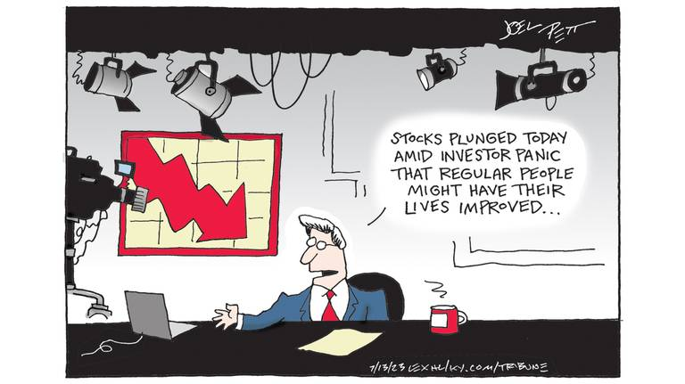  (Pett, “Wall Street v. Main Street”)  Works Cited:  Pett, Joel. “Wall Street v. Main Street.” Lexington Herald-Leader, 12 Jul 2023, www.kentucky.com/opinion/editorial-cartoons/joel-pett/. Accessed 18 Oct 2023.  Last-name, First-name. "Title if Any." Publication Name, date of publication, page number or URL if online.Accessed date.
 | Photography / digital photo images and prints  Photographic medium:  Publisher/Commission: | Embed image in text:    (Hussey, “The Soldier”)  Works Cited:  Hussey, Tom. “The Soldier.” Reflections, Hussey Photography, 2013, www.tomhussey.com/STORIES/REFLECTIONS/2. Accessed 18 Oct 2023.  Last-name, First-name. “Title of the Picture.” Story, Title of the Site, Date, URL. Accessed Date.
 | Blog / travel narrative writing and digital photo images | Quotations:  Quote from the blog “like this” (Perelman, “Shortened Title”).  Works Cited:  Perelman, Deb. “Our Favorite Chocolate Chip Cookies.” The Smitten Kitchen, 14 Jan. 2008, smittenkitchen.com/2008/01/chocolate-chip-cookies/. Accessed 26 Mar. 2025.  Last-name, First-name. "Title of Blog Post." Name of Blog, Blog Network/Publisher if given, date of post, URL. Accessed date.

Transitional Words and Phrases

Transitional Words and Phrases

Transitional language is important for clearly presenting complex  ideas by ensuring readers understand the logical connections and  reasoning that join each part of the composition in a meaningful sequence.  When papers lack transitional words and phrases, they start to read  like “choppy” lists of statements, or a mass of stand-alone paragraphs  about a topic. They might present a lot of different thoughts or  information, but they don’t show how these fit together to advance a  new, richer view of the topic (as proposed in thesis statements).  Improve clarity and cohesion—and avoid the dreaded “lack of flow”—  by using transitional words and phrases to create powerful links  between your ideas and help readers understand the paper’s logic.  Transitional language guides readers through complex ideas and  arguments by marking where you’re going and how you’re getting  there.  *In addition to improving clarity and cohesion, being purposeful and selective about your transition phrases in and between paragraphs will improve the ACCURACY, INCISIVENESS, and LOGICAL COHERENCE of your interpretive argument and analysis. One of IB examiners’ main criticisms of the HL essays has been the lack of accurate language and coherence of interpretive argument. | Use transitional words and phrases at the sentence- and paragraph-levels in your own writing to…  Build on the preceding text  Addition (of info or emphasis): also, and, in fact, indeed, moreover, in  addition, furthermore, besides X, both X and Y, above all, more/most  importantly  Example: such as, for instance, in particular, notably, consider, specifically,  for example, as an illustration  Clarification: actually, in other words, by extension, ultimately, in short, that  is (to say), namely, more precisely, to put it another way  Similarity: similarly, in like manner, likewise, equally, in the same way, by  the same token  Reference: regarding, considering, the fact that, as for, on the subject of  Contrast or challenge the preceding text  Contrast: but, however, though, equally, by way of contrast, while, on the  other hand, (and) yet, whereas, in contrast, (when) in fact, conversely,  despite, while, nonetheless  Concession: admittedly, granted, of course, although (it is true),  notwithstanding, even so, on the other hand  Dismissal: regardless, whatever the case, all the same  Make a causal connection  Causation/consequence: accordingly, as a result, consequently, thus,  hence, therefore, since, because, for this reason, as a result  Condition: (even) if, (only) when, on the condition that, in the case that,  provided that, in the event, unless, given that, inasmuch as, insofar as,  otherwise, if so  Indicate ordering  Sequence: first, second, third..., to begin, at first, initially, first of all,  subsequently, previously, after, before, next, then, eventually, at last,  finally, lastly, to conclude, as a final point  Retrospection: to return to, to resume, as previously stated/mentioned,  overall, in summary, briefly, given these points, as has been noted, in  sum, altogether, to summarize

Reverse Outline Quick-Check

Reverse Outline Quick-Check
Reverse outline quick-check:
Copy and paste your essay into a new document.
Bold the first and last sentences of each body paragraph.
  - Is the first sentence of each paragraph a topic sentence that identifies the main claim that paragraph makes in response to your line of inquiry and identifies the particular textual feature(s) you use as supporting evidence?
  - Does the last sentence (or sentences) of each paragraph relate its main claim or idea to the significant interpretation you propose in your thesis?
  - Does each paragraph contain direct reference to textual features that support your main claim or idea? Did you include parenthetical citations for each direct reference to the text(s)? Did you embed all quotations in your own sentences?
  - Are there links between the paragraphs? Look at the last sentence of each body paragraph and the first sentence of the following paragraph – one of them should contain a transitional phrase that links the two.
Consider possible changes in your paragraph ordering.
  - Go through your entire paper. In each paragraph, highlight in yellow sentence(s) containing the key idea. Highlight in green any sentences in each paragraph that do not directly connect or relate to that paragraph’s key idea already highlighted in yellow.
  - Copy and paste all yellow-highlighted and green-highlighted sentences in sequential order below.
  - Would it improve your interpretive argument if you put the paragraph with the most obvious evidence first and proceed to the least obvious? Would rearranging your paragraphs develop your interpretive argument more persuasively?

Highlighted sentences in sequential order

Argument Structures to Consider
Nestorian Order:
Second strongest point + examples, minor points + examples
Opposing theory/point + examples
Refute opposition by arguing counter points + examples
Strongest, best point + examples

Rogerian argument:
Introduce historical issue fairly and neutrally
Explain opposing views fairly + supporting examples
State your historical proposition/position; give strong reasons + compelling supporting examples
State your position’s advantages or offer a logical compromise

Strong Verbs & Embedding Quotations

Strong Verbs and Embedding Quotations
(Source: Gerald Graff and Cathy Birkenstein, They Say/I Say: The Moves that Matter in Academic Writing, 5th ed., W.W. Norton & Co., 2021.)

The following formula and templates refer to embedding quotations from secondary sources, but they are easily adapted to writing about literary works. The two groups of signal words below are excellent for incorporating strong verbs in your sentences!

Embedding quotations in sentences
When quoting a source in your writing, the quotation becomes part of the paragraph in which it appears. Since paragraphs are made up of sentences, you’ll need to embed the quotation itself in a sentence of your own making.
Embedding quotations places them in the context of your own writing. To embed a quotation in the sentence, identify the source and introduce the quotation with a signal word.

Strong Verbs: Common signal words

says (if quoting speech/dialogue) emphasizes claims acknowledges
writes suggests contends reports
states observes argues explains
remarks continues agrees/disagrees urges

Framing quotations in your writing
Frame every quotation to clearly present its relevance and meaning for readers by applying this two-part formula called a “quotation sandwich” (51). As if sandwiching ingredients between two slices of bread, for a “quotation sandwich” you insert the quotation between the introductory statement that introduces and embeds the quotation in the sentence, and a follow-up sentence that explains why the quotation is important and what you understand it to mean.

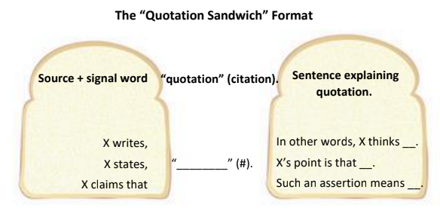

Pro Tip for using the “quotation sandwich” format in your writing

Notice that signal words appear in both sets of templates above. This is because signal words are descriptive verbs that introduce quotations as well as introducing summaries, explanations, and redescriptions of what was stated.

You can enhance the clarity, impact, and sophistication of your writing when explaining quotations by selecting more specific descriptive verbs that appropriately signal what you take the quoted author’s meaning or purpose to be.

Try this technique when you quote sources in your writing:
- Embed quotation: When introducing quotations, focus on presenting information about the source (such as title, topic, genre, author, where it appears in the story or text or series, etc.) and use a common or neutral signal word, such as the common signal words listed above.
- Follow up with analysis: Then, choose a more specifically expressive, emotionally-charged, and/or value-laden, signal word to introduce and reinforce your explanation of the quotation. The second group of strong verbs below provides a sampling of these more specific and expressive signal words.

Strong Verbs: Specific and Expressive Signal Words
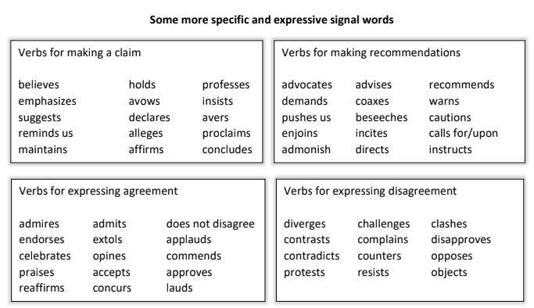

Templates for crafting a “quotation sandwich”: introducing and explaining

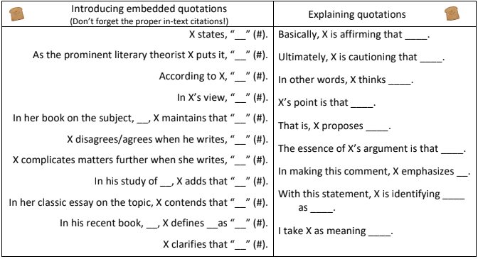
Writing Exercise for Drafting and Revision

- Make a couple more templates for introducing and embedding quotations using the lists of signal words and the formula:
Identify source X + signal word/phrase + “____” (#).

- Make a couple more templates for explaining or summarizing quotations using the lists of more specific and expressive signal words.
For example: By challenging ____, X advances her own view that _____.
In maintaining ______, X confuses _____ and _____.

- Apply the “quotation sandwich” model to the quotations and direct references in your HL essay.

Practice:
1. introducing the source and using signal words to embed the quotation in a sentence with proper punctuation and citation, and
2. following-up with a sentence that analyzes or explains the importance of the quotation and tells readers how you interpret its meaning and effect(s) on the reader/viewer.

Academic Essay Conventions

Lang & Lit Academic Essay Conventions
(adapted from Harvard Writing Center’s Brief Guide to Writing the English Paper, p. 6)

- Avoid plot summary. An essay that recounts what happened in a narrative work–or that analyzes selected scenes in the same order they occur in the work–is letting the novel’s author rather than the essay’s author structure the paper’s argument. Instead, you can focus on selected scenes, briefly identifying them before analyzing significant details. Resist shadowing the narrative’s/work’s chronology in your own paper. One rule of thumb is to begin with the most obvious piece of evidence and move progressively to the least obvious piece of evidence.

- Avoid basing your argument on opinion. Sometimes works provoke personal feelings and opinions in a reader/audience. When this happens, the reader should try to suspend those personal feelings and opinions as they close read, paying attention instead to structures and features in the text. Textual evidence and not personal conviction should be the basis of your thesis and argument.
These works don’t tell you what to feel or think; they show or provoke feelings and lines of thought. Look for the authorial choice / textual feature, technique, device, language, form, etc., that provokes or models the thoughts and feelings as effects on the reader.

- Distinguish between “speakers” and authors. Because English papers make claims about texts rather than about authors, poems and narratives have a “speaker” or “narrator” who should not be confused with the author. David Copperfield, while he has autobiographical features, is not Charles Dickens himself.

- Write in the present tense. Because English papers approach literary works as linguistic artifacts rather than as historical documents, they discuss characters and events in the present tense rather than the past tense. For example, one might write: “In The Stranger, Mersault expresses disdain for the conventional concerns of those around him.”

- Use MLA style citations. Because English papers quote frequently, often from the same text, they cite page numbers parenthetically. For example: In The Stranger, Mersault expresses disdain for conventional social expectations and instead ultimately opens himself “to the gentle indifference of the world” (122).

Access examples of academic language for every section and purpose:

PhraseBook for Writing Papers and Research in English (PDF found online; hard copies also in the Writing Lab)

University of Manchester Academic Phrasebank

